Az900 Important points

1)

Azure Load Balancer

Fully managed Service

* Internal Load Balancer: From Internal VMs only
* Public load Balancer :- From internet to VMs

2 types

* Basic only 1 VM, Scale Set , Availability Set
* Standard as many Vm as You want
* All VMs must be In same Region and availability set .
* For standard Load Balancers the IPs must also be of kind Standard Type
* Normally Load Balancer works at layer 7 Application Layer
* Azure Load balancer works at layer 4 Transport Layer

2)Azure APPlication gateway

Fully managed service

* URL based routing
* Web based firewall

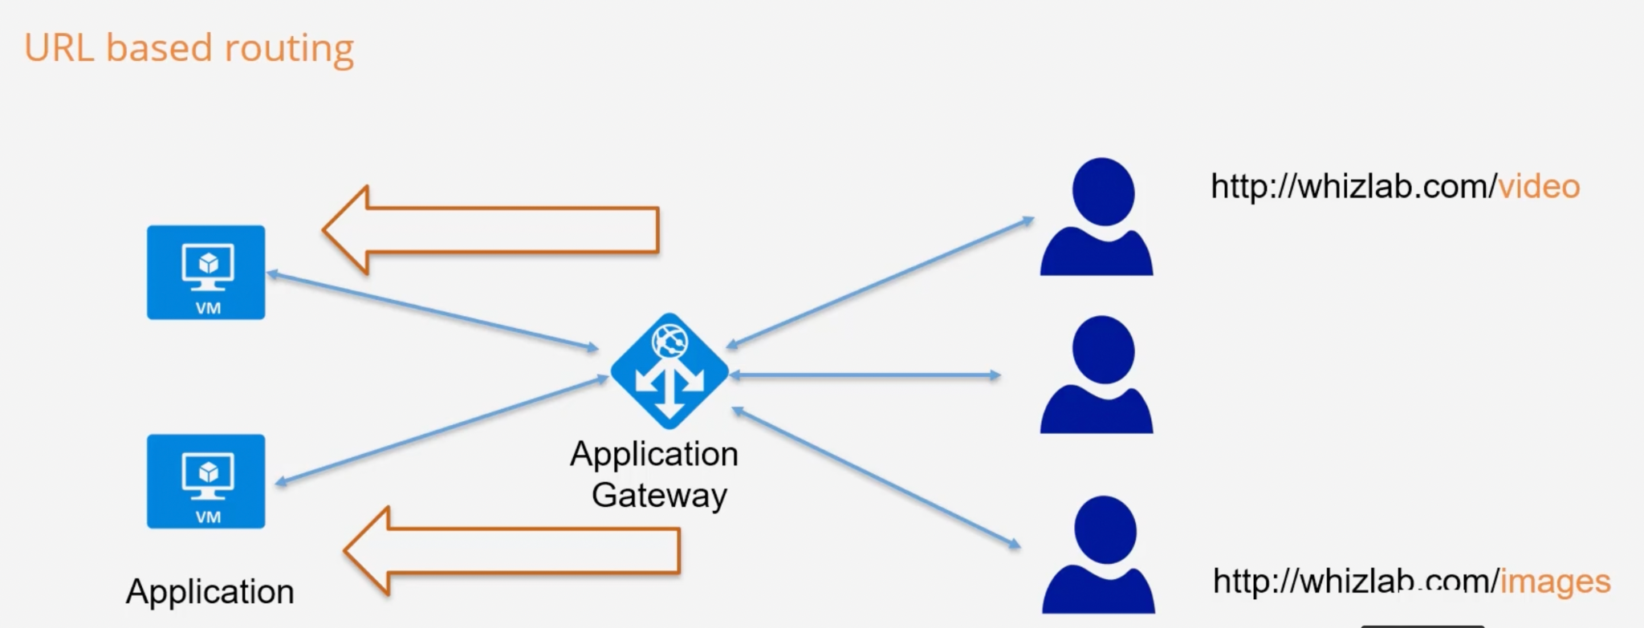

Azure Storage Services

Storage resource ⇒ Must have a unique name.

Create Storage Account —> create Containers—----> then store data

* Blob (Binary Large OBject) :- Unstructured data like images, audio,video,log files etc.
* Table :

Used for strong the Unstructured NoSQl data

This is a ky attribute store

Cost effective option for storage of table like data for applications.

* File :

Allows to retrieval of files via the Server Message Block Protocol

You can mount files shares on Windows, Linux, Max based machines.

Here you don’t need to manage file servers.

* Queue :

Service used for storage and retrieval of messages.

Good when you want to decouple components of a application

A single message in the queue can be upto 64 KB in size (means only text messages).

Can store millions of messages.

While uploading an object in Azure Blob storage , it states select a file, Don’t confuse between that is this BLOB object or File , don’t worry it is BLOB object only .

Access Tiers

* Hot :
  + For frequently used objects
  + Costs more
* Cold :
  + For infrequently used objects
  + Cost less

* Archive :-
  + Ideal for Rarely used data like backup data
  + Can be set only at the object level not at the Container Level
  + Cost Least
  + If objects is marked Archive then objects needs to rehydrated to hot, cool access tier to use it further

File Service :

Add the files and you can connect to it with all 3 types of OS , Linux bases, Windows ,MacOs.

We can set quota as well

Table Service:

Used for NoSQL data .

We can’t add the data directly unlike file service , and need to use Azure storage Explorer.

Azure storage portal is available on Azure portal and is a Stand Alone tool as well .

VPN Gateway :

This is used to connect your on-premise network to an Azure network .

The traffic sent via the Gateway is encrypted.

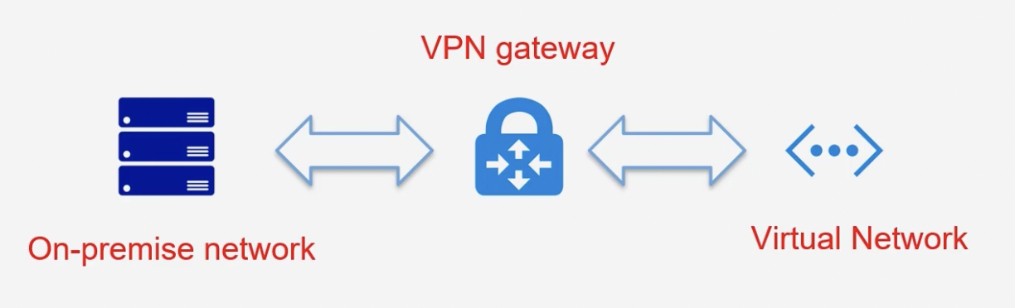

VPN Gateways

(Virtual Private Network Gateway)

Traffic sent via the network is Encrypted .

To establish connectivity with On premise network and Azure Virtual network , in case we are not able to shift whole on premise .

Used where Hybrid

Types

Point to site

Used to connect Workstation to Azure workstation

Site to site

This used to connect on premise networks to Azure networks.

Traffic is encrypted using IPsec protocol

On premise network should have a VPN device with an IP address that is routable over the internet.

Virtual Network Peering

To connect with VMs

1 ways : connect using a public IP address.

2nd way :communicate using Private Ip address

Virtual Network Peering can connect with

Different virtual networks .

Virtual networks which are either located the same Azure region.

Azure ExpressRoute

The service allows you to extend a company’s on premise network to MS cloud using a Private Connection that is provided by a connectivity Provider.

The connection allows you to connect with MS services such as MS azure or office 365 services .

The connection uses layer 3 routing .

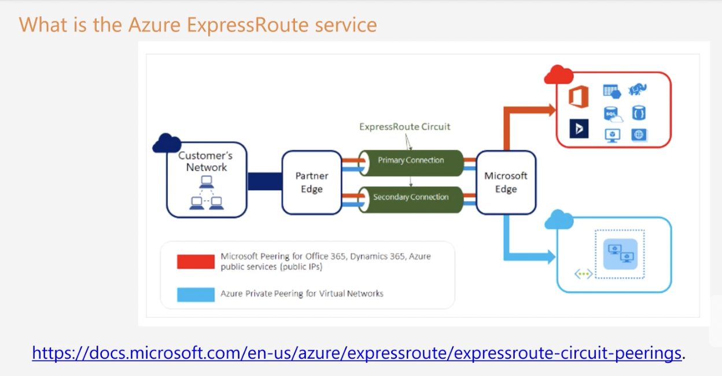

Core Services Part 2

**Azure web Apps**

**Azure web Apps**

2 Resources are allocated while using Web Apps

1. Azure Web app service
2. App service plan

Select a Azure Web App service plan

Devops is possible ⇒ Continuous Deployment

Blue green Authentication is possible

Authenticate using external providers -Azure AD,Facebook,Google.

Key Terms When it comes to Azure Virtual machine

Host Pool

App groups

RemoteApp

FullDesktop

Workstation

End users

**Azure Databricks**

This is Spark based analytics platform that is optimized for Microsoft Azure Cloud .

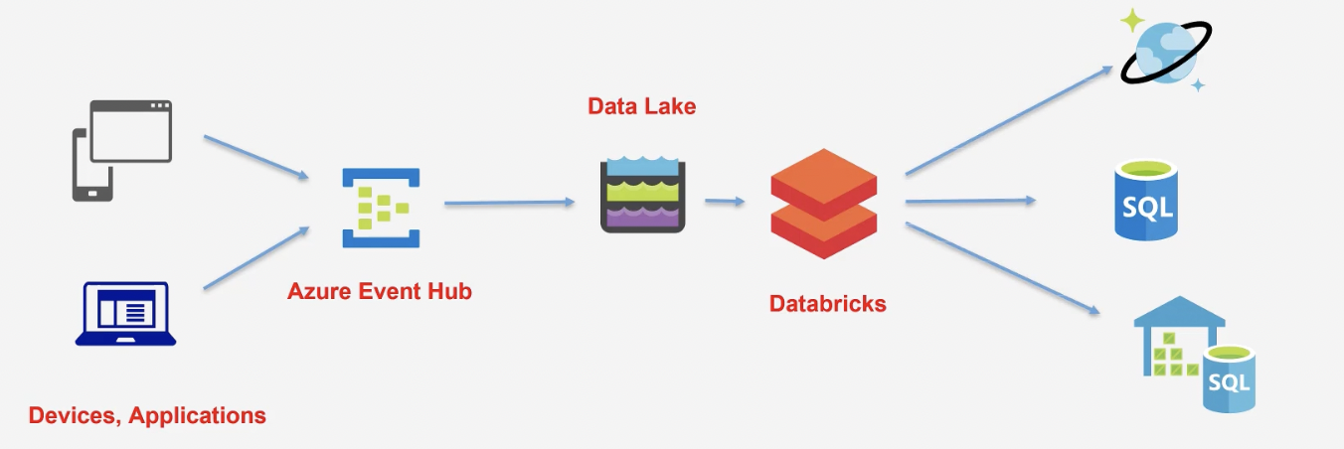

With Azure databricks you can create managed Apache Spark clusters.

You can dynamically automate clusters .You can also create serverless clusters and also share them across teams.

You have easy data exploration with the help of notebooks in R, python, scale and SQL.

You can use interactive dashboards to create dynamic reports .

It has security aspects when it comes to Role based access control and integration with Azure Active Directory .

**Azure HDInsights**

This is a hadoop based component.

This service makes it easier to process large amount of data

This service is based on open source frameworks of Hadoop, Apache spark, Apache Hive, Apache Kafka, Apache Storm, R etc.

You can create Azure HDInsights clusters for batch processing needs.

These clusters are created on-demand. So that we can save on Costs .

**Azure Resource Manager (ARM) Template**

This is a JSON (JavaScript Object Notation) template that contains the resources that you want to create in Azure .

You can then submit the template to Azure Resource Manager .

Azure Resource Manager will then create the resources based on the template definition.

This is good when you have a need to repeatedly need to create the same set of resources - Test environment .

The Different elements of the template

**$schema** - this describes the version of the template language .

**contentVersion**- This the version of the template

**resources**- This is the main section where you define the resources that need to be deployed as part of the template .

**Parameters**

These are the values that can be provided to the template that can be used to customize the deployment of the resources.

**variables** - These are values that can be reused in the template .

**functions**- These are user defined functions that can be used in the template .

outputs- These are values that are returned after the deployment.

Azure Cognitive Service

These are set of services in Azure that helps you to build cognitive intelligence in your applications.

Here you don’t need to have a much knowledge in Artificial Intelligence to use these services .

5 Types:

Vision

Speech

Language

Search

Decision

Computer Vision API:

Api for image processing

It can get information from the images by processing the images.

Or even it can extract text from images.

Speech service :

Provides speech service to an application.

It includes capabilities such as translating speech to text.

Or even converting text to speech .

It can also perform speech translation as well.

Language API:

Allows Text analysis

Understand Text sentiments as well

Decision API:

Here you can check for different aspects i the content .

For example : You can detect any abnormalities in the data collected .

You can also use the Content Moderator to monitor for offensive language .

Search API

Bing News Search : Lsit series of news articles based on a user’s query.

Bing Video Search: This can be used to list a series of video articles based on a user's query.

Bing Search : this can be used to list series if search results based on a users’ query .

Azure DevOps

Azure Boards - Here teams can create and track user stories , backlog items, task, features and bugs that are linked onto a project .

Azure Repos : This is a set of version control tools that helps you manage your code .

Azure Pipelines: This can be used to automatically build and test your code project .

Azure Test Plans : Here you can manage manual testing which includes User acceptance testing, Exploratory testing and Shareholder feedback.

Azure Artifacts - Here you can create and shared Maven, npm and Nuget package feeds from public and private sources with teams of any size.

Azure DevTest labs

This is a service that allows developers or teams to get up and running with the resources such as Azure virtual machines without waiting for approval .

With DevTest Labs, you can create labs based on pre configured Azure Resource Manager templates .

You can also set policies on the number of machines that can be created .

You can set auto Shutdown and auto start schedules on VMs.

‘

Azure Serverless Services

* Here you don’t need to maintain the underlying physical infrastructure.
* You also don’t need to manage the underlying software hosted on the compute infrastructure.

Serverless solutions from Azure

1)Azure Functions: This is serverless compute service.

Here you can deploy your function code onto Azure .

Here you only pay for the amount of time the code runs.

2)Serverless Kubernetes

Kubernetes is used for deploying your container based application

This is a serverless version of kubernetes that is also available.

3)Azure logic apps:

This is used to design workflows in Azure .

Business users can create workflows ad integrations .

Workflows can connect to a variety of Azure services and third party services as well.

Azure Event Grid: This is the event based service in Azure

Here you can work with events generated from Azure services .

Azure Api management

To manage backend APIs .

Azure SQL databases

Apart from Paas , There is a serverless version of Azure SQL database.

Here you only pay for the compute used .

You can pause and resume workloads on the database.

Azure Cosmos DB

Here also they have a serverless Pricing option available .

Azure Functions

Used when you are required to run a code we use Azure functions .

Binding

Input Binding

Output Binding

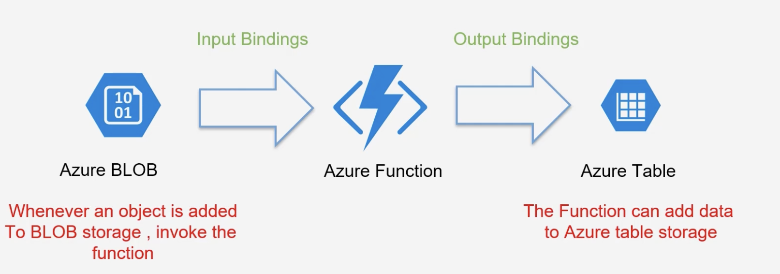

Plans for Azure Serverless

Costing : Consumption plan or App service plan.

Consumption plan- You only get charged for the number of executions, execution time ,Memory used.

Consumption plan — Maximum allowable execution time is 5 minutes.

App service Plan - Have Instances allocated , Have the function running for a longer time , using more memory .

Azure Event Handler

You can take advantage of the Event Grid Service to listen to events emitted by Azure Services .

You can subscribe to various events published by Azure services .

You can then define an Event Handler that can be used too process the event .

You can also define your own custom events .

This services is a highly available service because it is spread across multiple fault domains and availability zones in every region.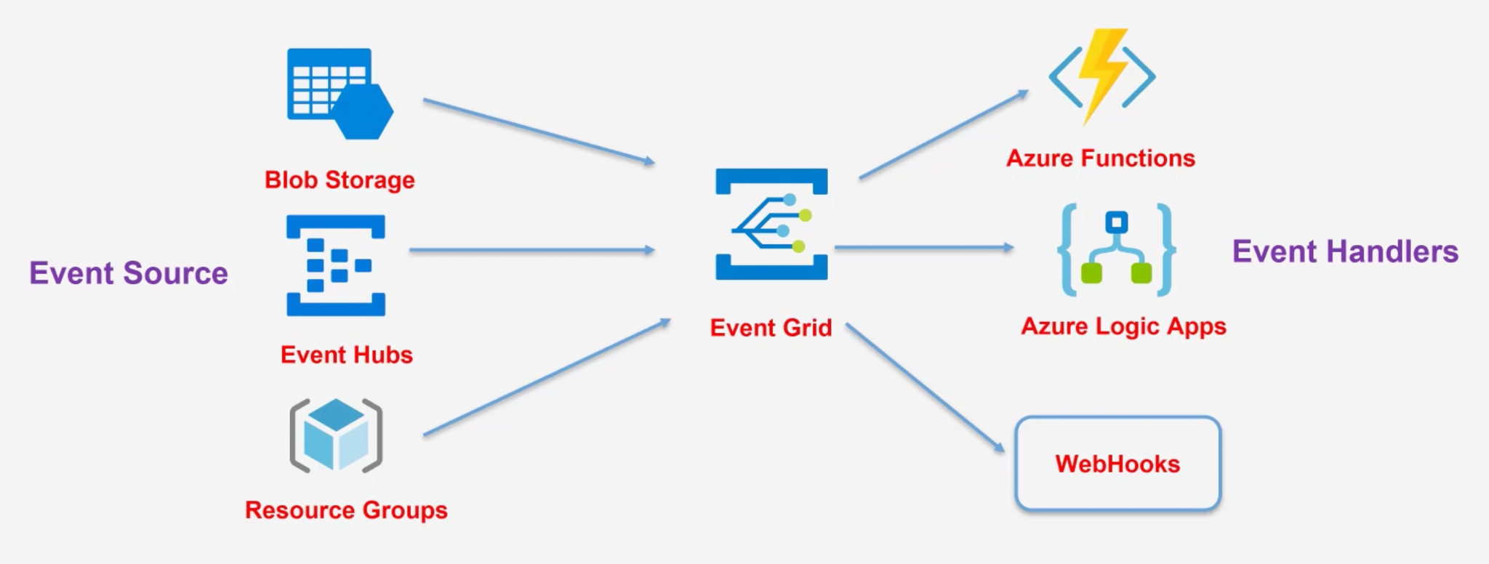

Azure Logic Apps;

Helps us automate and orchestrate tasks .

Helps to build workflows

Various templates already available to build workflows .

Fully managed Azure Service .

You can build workflow and don’t need to worry about the infrastructure to store the workflows.

Workflows can integrate with various Azure Services and third party services as well.

You can build workflows via a visual designer .

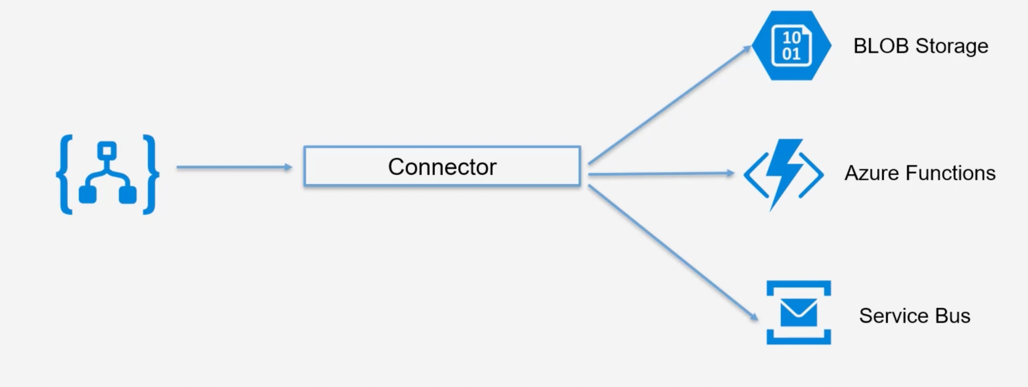

Parts:

Triggers -

Some of the connectors like Azure BLOB storage have the facility to trigger the Azure Logic apps

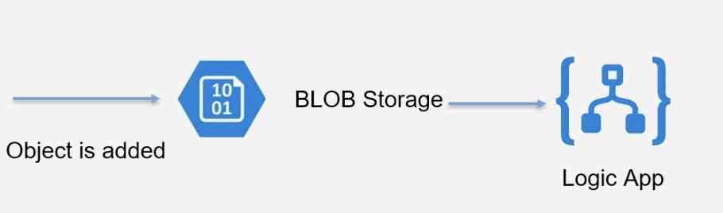

Actions: —

What to do when an event is triggered .

Do you want to send an email to the IT administrator on the event ?

Do you want to call Azure Functions?

Azure Cosmos DB :

Multi model database

Low latency access to data

Instant replication of data across regions.

Scales based on demand.

Fully managed and serverless.

Multi Model DB

We can use table Api to store Table like Data .

SQL api to store sql queries.

Or could even store data based on the Mongo Api .

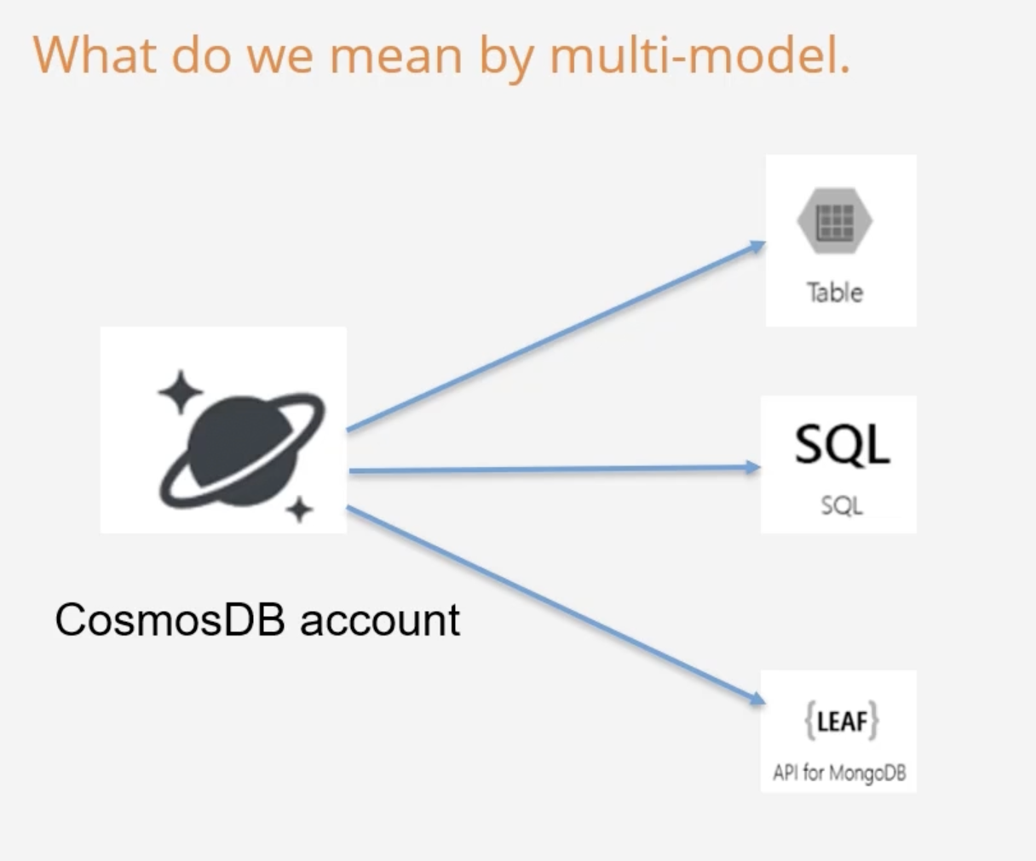

Features of Cosmos DB :

Provides 99.999% availability for reads and writes .

Ability to scale from thousands to hundreds of millions of requests/sec.

Cosmos DB guarantees less than 10 ms latencies for read and indexed writes at the 99th percentile .

Work with Various API’s - SQL , Mongo ,cassanddra , GREMlin and Table.

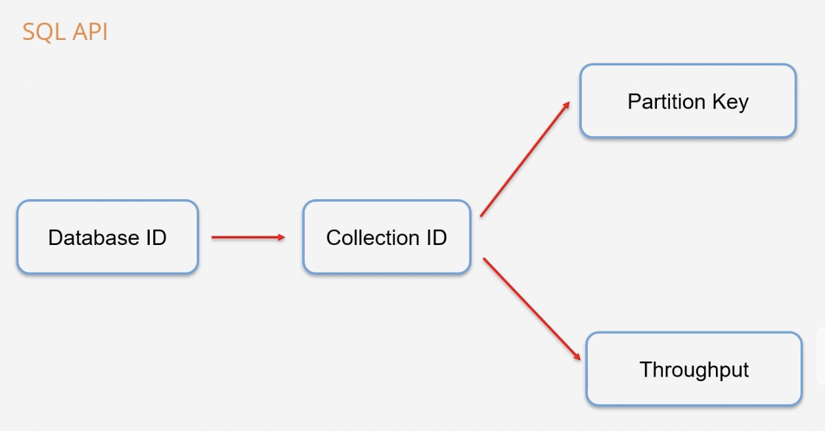

Throughput

This ensures CosmosDB allocates the right resources .

The throughput is a combined measure of CPU,Memory and IOPS.

Helps have an even measure no matters which API you choose

The throughput is measured in Request Units .

The cost to read a 1-KB item is 1 Request unit .

Billing is done on an hourly basis.

Azure SQL Database

PaaS

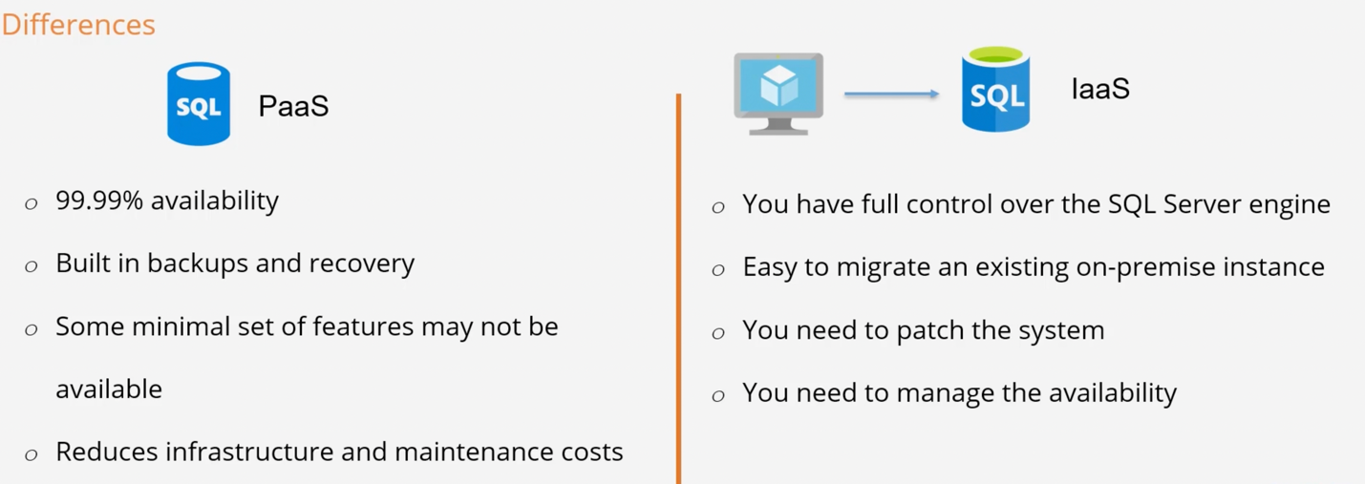

We in Iaas we have full control over SQL engine in Pass Azure has control over sql engine .

Easy to migrate an existing on premise instance on Azure (SQL version )

IMP : We need to patch the system.

(A **patch** is a set of changes to a computer program or its supporting data designed to **update**, fix, or improve it. ... This includes fixing security vulnerabilities ...

)

Elastic pool : Allows you to share compute and storage among Various Databases.

Pricing :

DTU : Database Transaction Unit – Bundles measure of compute, storage and IO resources.

Good for companies who just want a simple option of managing their underlying resources.

vCore based model - Here customers choose the amount of computer and storage .

this gives more flexility and control to the underlying resources

The vCore model is also ideal if you have existing SQL Server licences. .

Connect and Work:

Use the traditional tools just like working with an on – premise database .

SQL server Management Studio

Visual Studio IDE

.NET program

Creates two resources:

SQL server

SQL database

Important

Every time you try to connect to SQL service in Azure , make sure to add a firewall rule for allowing your IP to connect to the server .

Azure database for MySQL

This is a platform as a service that is available for the MySQL community Edition.

Here you get built in high availability.

You also get automated backups and point in time restore for 35 days.

The underlying service is responsible for maintaining the underlying hardware and keep the database engine up to date.

Here the company does not have to bear the overhead of maintaining the underlying infrastructure.

Important

Every time you try to connect to SQL service in Azure , make sure to add a firewall rule for allowing your IP to connect to the server .

We can use MySQL workbench for using this tool .

Azure Database for PostgreSQL

This is Paas that is available for the PostgreSQL community edition.

Here you get the built in high availability .

You also get automated backups and point in time restore for 35 days .

The underlying service is responsible for maintaining the underlying hardware and keeps the database engine up to date.

Here the company does not have to bear the overhead of maintaining the underlying infrastructure.

Important

Every time you try to connect to SQL service in Azure , make sure to add a firewall rule for allowing your IP to connect to the server .

Azure Data studio

A cross platform database tool for data professional using the on-premises and cloud data platform on Windows, Mac Os and Linux.

Download the tool

Add the extension for different servers.

Azure SQL managed Instance

This is again a cloud based service for hosting a SQL database .

Here the main benefit is that the underlying database engine has near **100 % compatibility** with the latest SQL server enterprise edition database engine.

This makes it easier for companies to lift and shift their existing SQL Server workloads onto Azure.

It also provides native Virtual network implementation.

(Provides more safety n isolation which companies may prefer)

Here you get the feature of high availability and backups.

Offers Azure Hybrid Benefit option: you can select if you have a SQL server license.

Takes a long time to deploy (6hours+)

Azure SQL Data warehouse

Enterprise Data warehouse on Azure

Used to store petabytes of data.

Perfect data store when you want to have an end-to-end big data solution on Azure.

Data is stored in relational tables using columnar storage.

Storing data in such a way reduces the storage costs and improves performance.

You can perform query analysis over large data sets.

Remember that the data warehouse is not used for transactional data.

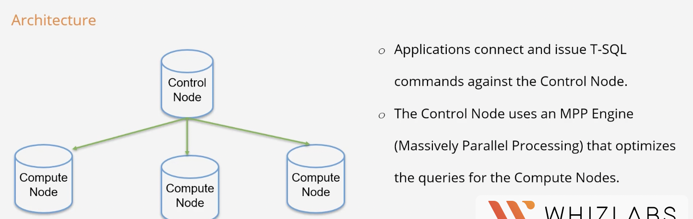

Azure Synapse Analytics

This is an analytics service that helps enterprises build data warehousing and Big Data analytics solutions.

There are currently four components of Azure Synapse.

Synapse SQL – This is a complete T-SQL based analytics solution.

Spark- This is the Apache Spark System.

Synapse Pipeline: This is used for Hybrid data integration.

Studio – This is a Unified used experience.

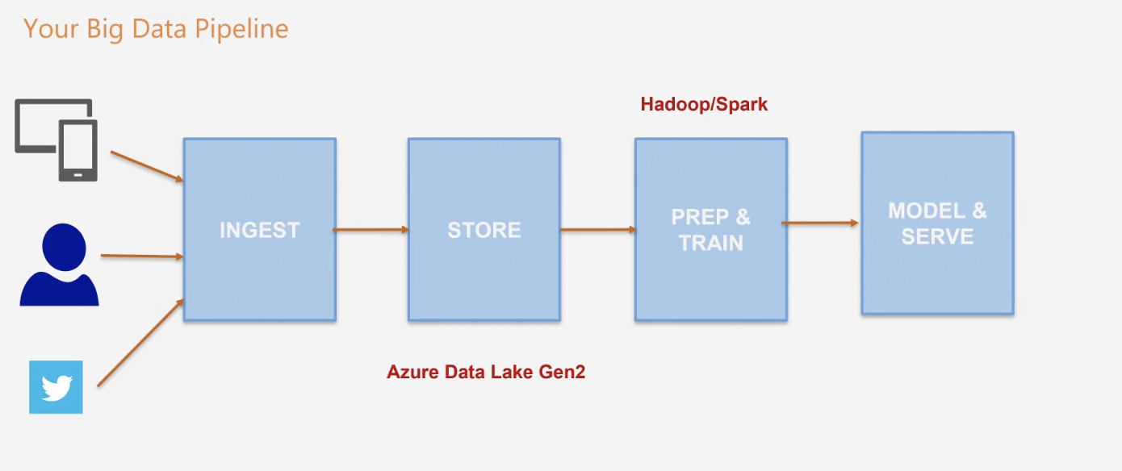

Synapse SQL pool:

This represents a collection of analytic resources that are provided when using Synapse SQL.

You can import big data into the pool with use of PolyBase T-SQL queries.

Your business can gather insights on the data stored in the SQL pool.

Synapse SQL MPP architecture

Synapse SQL uses a node-based Architecture.

Here the applications or users connect and issue T-SQL commands against the control node.

The control node runs the MPP engine. The MPP engine then optimizes the queries for parallel processing.

The operations are then passed to the compute node to perform the required work.

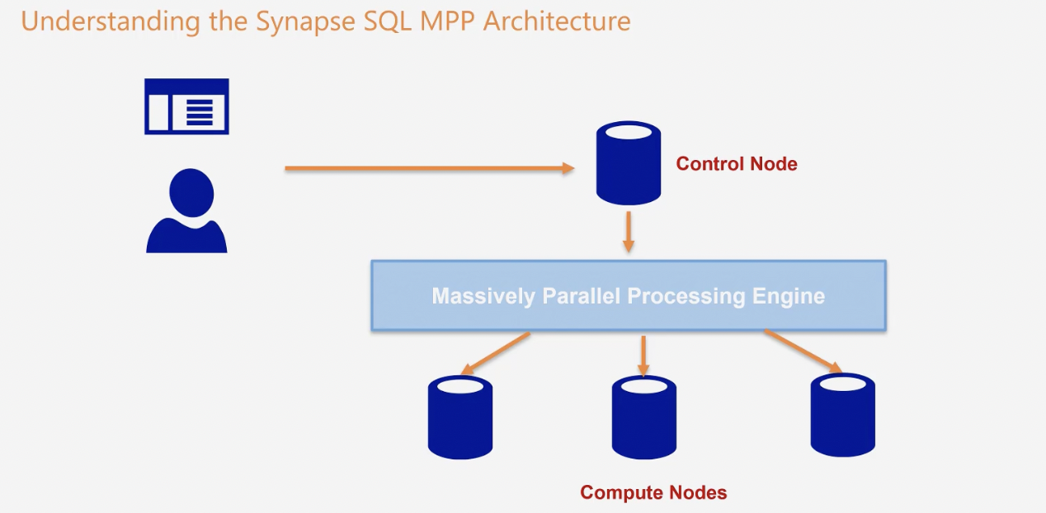

Data warehousing unit

A data warehousing unit is a bundle of three resources CPU, memory, and IO.

When you create a SQL pool, you have to mention the number of Data warehousing units you require for the pool.

If you want higher performance for your pool, you can increase the increase the number of units at any point in time.

Azure Content delivery network (CDN) service

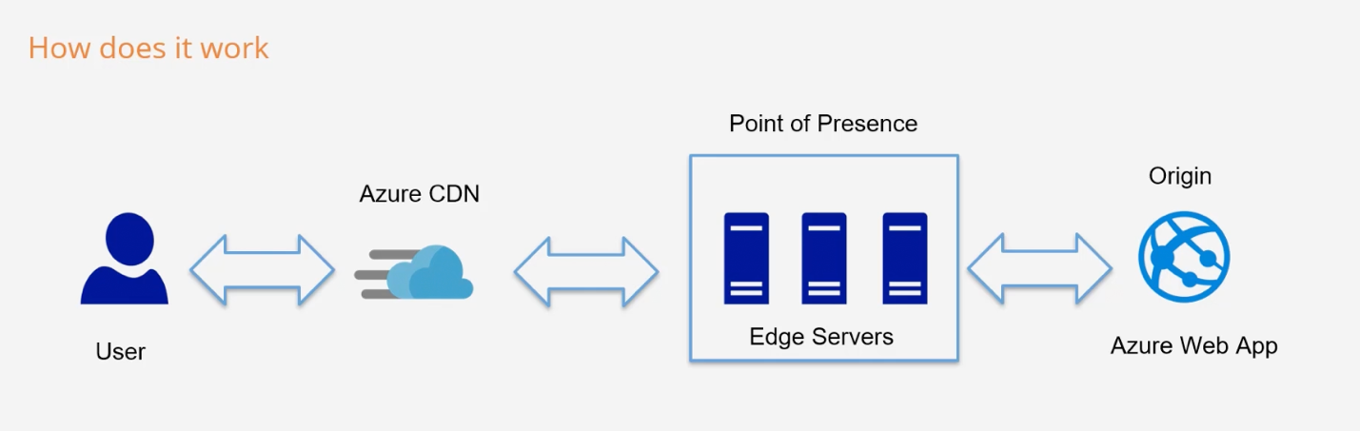

How does the flow work

If the request is made from the user to the Azure CDN endpoint, the request it sent to the closest point of presence. This would be closest to the location of the user.

If the edge server in the Point of presence does not have the resource, then the edge server will contact the origin server to get the resource.

The resource is cached on the edge server and also sent to the user.

The resource will be cached in the Point of presence based on the TTL(Time to Live)

Creating a CDN

You first need to create a CDN Profile.

You then create a CDN Endpoint – Existing Web app, Storage account or another origin.

You can attach multiple endpoints to the profile.

Azure IOT tools

IoT Hub

Machine Learning Service

Machine Learning Studio

IoT Hub:

Central message hub

Used for bi-directional communication between the IoT application and the IoT devices.

Fully managed service hosted in Azure

Ability to consume millions of messages

Enable per device Authentication – SAS tokens, x.509 certificates

Control over device access.

Machine learning service

Service used to train, deploy, automate, and manage machine learning models.

How does the typical framework work?

You develop machine learning scripts in python

Create a compute target

Submit the script to the target.

Query the experiment

See if it meets the desired results

If not, change the scripts and run the scripts

If the script gives the desired result, register the persisted model in the model registry.

Machine Learning Studio

Simple drag and drop tool

You can also use this tool to build, test and deploy predictive analytics solution on your data.

You can easily drag and drop data sets.

You can easily drag and drop sets

You can also drag analysis modules onto an interactive canvas

All of this forms an experiment, a training experiment in the beginning

After running the training experiment and you are happy with the results, you can convert the experiment to a predictive experiment.

Big Data Tools:

Azure SQL data warehouse

Azure HDInsight

Azure Data Lake analytics

Azure HDInsight

Fully managed service, open-source analytics service

You can use the service to run frameworks such as Hadoop, Apache Spark, Apache Hive, LLap, Apache Kafka, Apache Storm, R .

Instead of creating the cluster and installing the Hadoop framework we can use the Azure HDInsights which will automatically give you the platform in which you can do the Hadoop framework.

Built with full redundancy and high availability.

The service automatically deploys a cluster of virtual machines

Azure Data Lake Analytics

Allows you to run queries on terabytes to petabytes of data.

It uses a U-SQL language that is similar to SQL.

You can use tools like Visual Studio to work with Data Analytics.

Azure Management Tools

1. Azure portal - This is the web or browser based experience
2. Powershell -Command line and Scripting purposes

You can also use Powershell for Azure. You can run Powershell on Windows, macOS and Linux based machines.

To use powershell we need to install the Libraries and dependencies.

Good for IT administrators for running the automation Scripts.

1. Azure command line interface: This is a specific command line interface for Azure.

You need to install the required tools for using Azure Command Line interface.

1. Azure cloud shell

Can be accessed from Azure portal itself .

Azure Container Instances

This is a service that allows you to easily deploy containers in Azure.

Here you don’t need to manage the underlying virtual machines for hosting the container instances.

The container groups deployed via the Azure Container Instances gets an IP address and a fully qualifies domain name.

Here you can deploy both Windows and Linux containers.

Azure Kubernetes Service

This is a tool that is used to manage container based applications.

This is ideal tool that teams use to deploy microservices-based applications.

The Kubernetes service provides support for both stateless and stateful applications.

Azure Kubernetes service provides a managed Kubernetes service on the Azure cloud platform.

This helps reduce the complexity that is involved in deployment and working with core management tasks.

Pods: This is used run an instance of the application. The pod represents a single instance of the application. Normally each pod is mapped to a single container.

Deployment – This is used to represent the deployment of one or more identical pods.

If the Kubernetes scheduler finds out that pods or nodes encounters any issues, additional pods are created on healthy nodes.

Understand Security, Privacy, Compliance and Trust

Authentication and Authorization

Authentication: This is a process of identifying a user.

1. How does the Application know whether the user is really who they say they are?
2. So, this is done via Authentication
3. The simplest form to allow the user to enter a User name and password

Authorization:

This is a process of giving access for resources for the user identity.

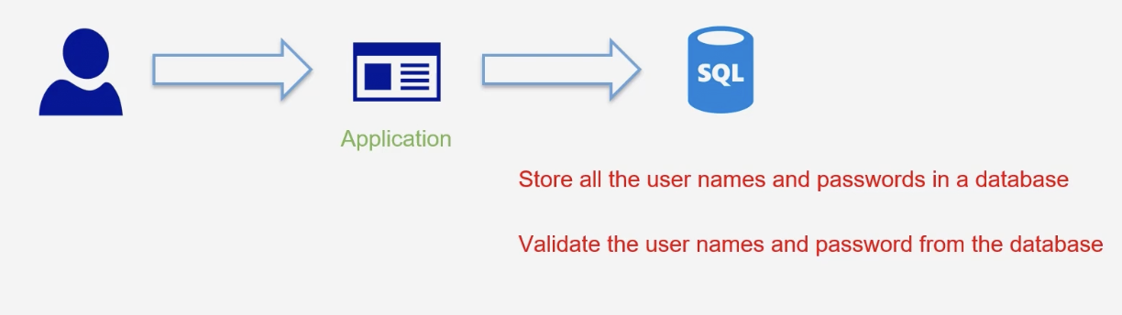

Azure has a simpler way to do so, i.e.

By Azure Active Directory (AD)

Azure AD

Identity and access management service.

You can manage access for the users to the Azure portal or to other apps like Office 365.

You can also manage access for internal applications

Azure AD has a lot of features that go beyond simple password management.

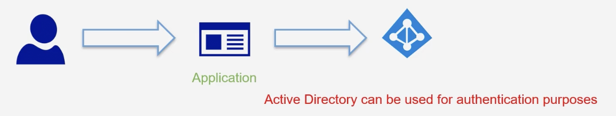

Azure AD Free – User groups management

You can synchronize users from your on-premises environment

You get basic reports

You can also get Single sign on capabilities.

Azure AD basic

Azure AD basic

Control access via groups

Self-service password reset feature

Azure AD premium P1

Supports Dynamic groups

Cloud Write back capabilities

Azure AD premium P2

Identity Protection – Provides conditional access to application (like Multi Factor Authentication)

Privileged Identity Management – help discover, restrict, and monitor administrators and their access to resources.

Azure Sentinel

This a cloud native security event management and security orchestration automated response solution.

Usage of workbooks – Here you can create interactive reports with the data that is collected by the service.

Analytics – Azure Sentinel can correlate alerts into incidents. There are many in-built rules to detect for threats. You can also define your own custom rules.

Playbooks – You can also perform security orchestration with the help of playbooks.

Lab:

Go to Azure sentinel service and create a log Analytics workspace

From which sentinel will check for the threats.

Once created click on Add.

Now you get dashboard for sentinel.

Azure Security Centre

Get security recommendation for improving safety of Azure Account

Azure Firewall

This is a fully managed cloud-based network security service.

This can be used to protect your resources in an Azure virtual network

Within this service you can create and enforce application and network connectivity polies.

This service can automatically scale up based on demand.

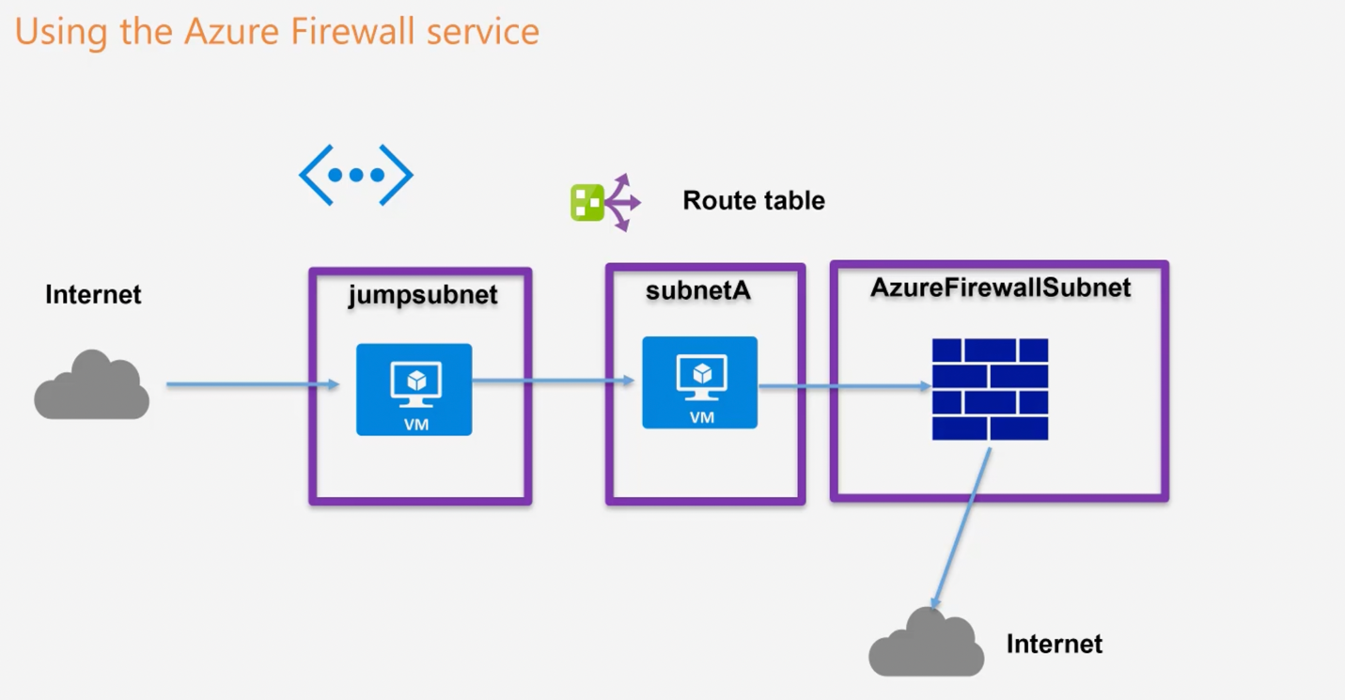

When we go and create a new user

Things to remember:

Username is going to like <username>@user2010gmail.onmicrosoft.com

Where [user2010@gmail.com](mailto:user2010@gmail.com) is an admin who is creating the new user.

2)When a new user is created by Azure AD it is by default have no Authorization to any kind of services.

This can be solved by

RBAC

Role based Access control (RBAC)

Provides a mechanism to provide access to resources.

There are many inbuilt roles available.

Example- if you want a user to perform management activities for virtual Machines, there is a Virtual machine contributor role.

You can also create your own custom roles.

You can create roles at different scope levels

Subscription level

Resource group level

Resource level

Broad categories on RBAC

Owner role: User can manage everything

Reader role: The user can view everything only

Contributor role: The user can manage all resources

Any many more roles refer to MS documentation

We need to give an IAM permission for the user at what so level we want.

Multi Factor Authentication

Provides an extra layer of security during the authentication process.

Ex: Enter user

Enter pass

Enter security code received on registered mobile number.

Code is required to complete authentication

Do activate Multi factor authentication

We need conditional access policies

And it is only available In Azure AD Premium P2 License.

Azure Key Vault:

Helps in Secret management

Key management

Certificate management

Secrets backed by Hardware security Modules.

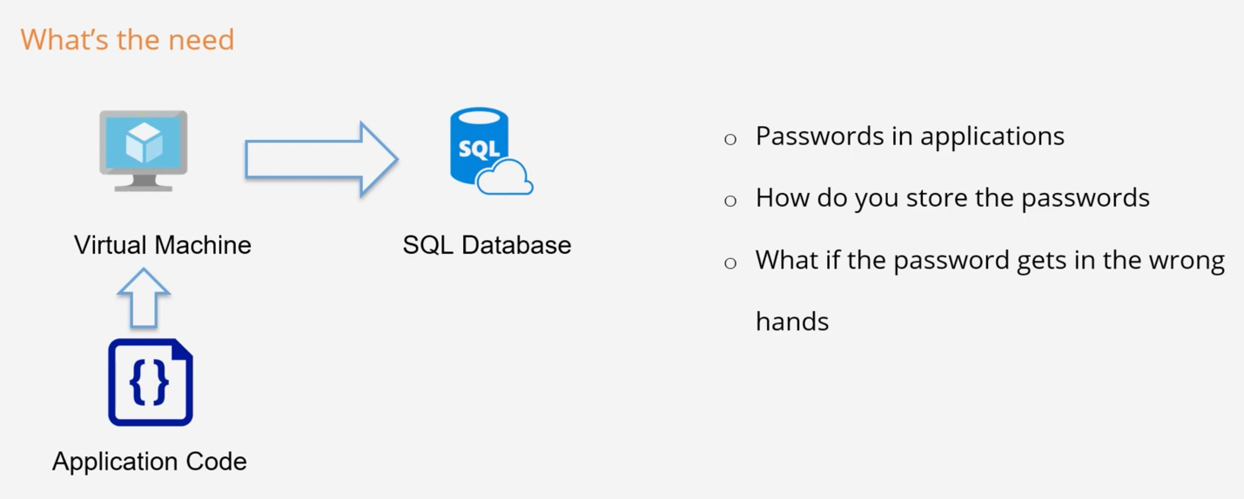

In order to encrypt the data, you need a Encryption key.

And then using encryption key and encryption algorithm to encrypt the data.

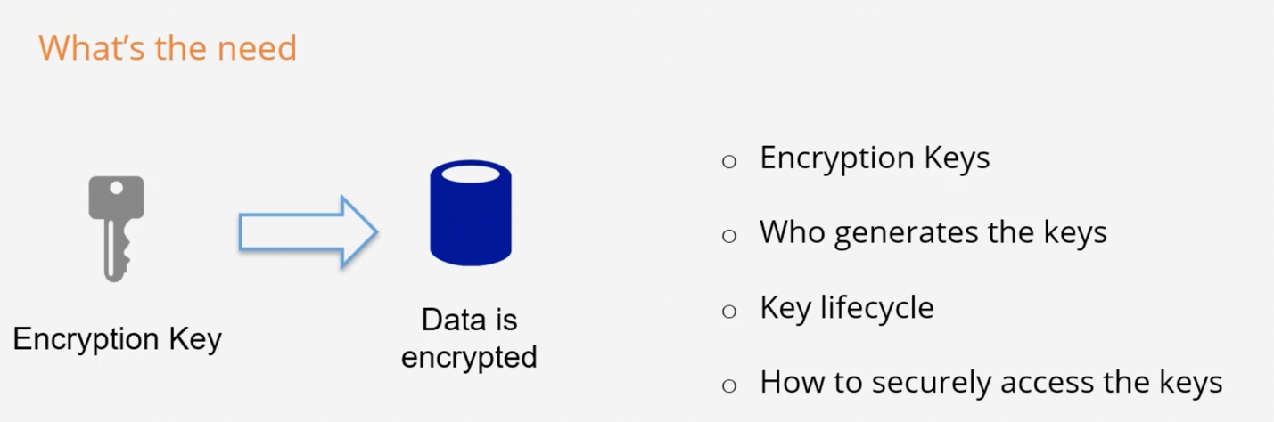

What can we do with Key vault service?

Securely store the secrets and passwords.

Control access to tokens.

Create and control Encryption keys.

Provision mange and deploy public and private Secure Sockets Layer/Transport Layer Security (SSL/TLS) certificates.

You can also control access to secrets, keys In the key vault.

You can also integrate the Key vault with other services

With Azure Storage, you can use the Encryption section to specify your own keys in the Key vault.

Compliance

GDPR-

General Data protection Regulation – Law on data protection and privacy.

ISO-

International organization for standardization – independent, non-governmental organization. The members of these organization are form various countries. They meet to provide common standards between nations.

NIST-National institute for standards and technology

Azure service trust Centre: To get the Audit reports for the Azure Security and data privacy policies.

Azure Government

Govt needs more safety and security so they can use the Azure Govt , but they are subject to availability.

Azure Security Tools

Azure Firewall

Fully managed service that can be used to protect resources in an Azure virtual network.

It’s a service has high availability and automatic scalability.

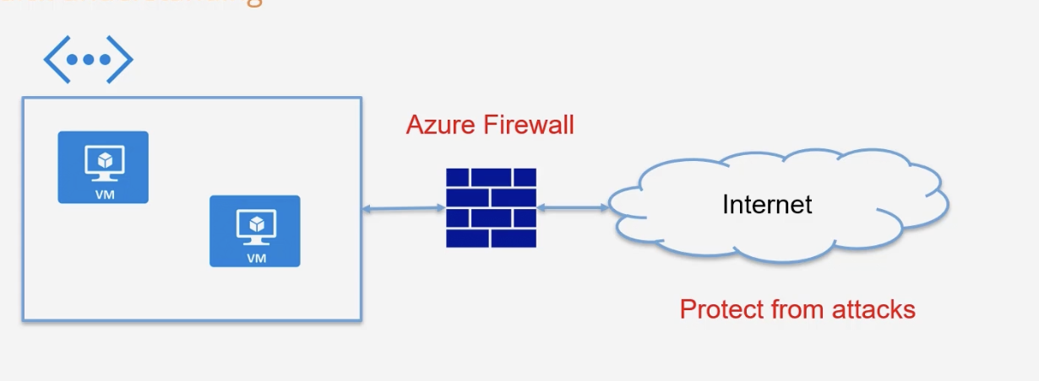

DDoS protection

Basic protection that is always enabled.

Real time monitoring of traffic and mitigation of common network-level attacks

This offering is free.

Standard protection

This is available for a fee per month.

Here you can get real time metrics and diagnostics log via Azure monitor

Post attack mitigation reports

Access to DDoS experts during an active attack

Azure Security Centre

Security management system

Does an assessment of the resources hosted in Azure and decides whether they are secure or not.

Raises threat prevention recommendation and threat detection alerts.

Azure Advanced Threat Protection

Cloud based security solution

Used to protect identities stored in Azure AD.

Identify and investigate suspicious user activities.

Azure Policies

Azure Policies provides governance for your azure account.

1)There is a mandate to ensure all resources have a department tag.

2)Due to cost constraints, no one should be allowed to create a Virtual machine which has higher capacity.

3)No one should be allowed to create Azure SQL server instance in a particular resource group.

Organizing your resources

Using Management groups

Using Management groups is useful when a company has many subscriptions.

You can club the subscription under management groups.

This helps to manage the access, policies and compliance for those subscriptions.

When you group the subscriptions under a management group, they inherit the conditions that are applied at the management group level.

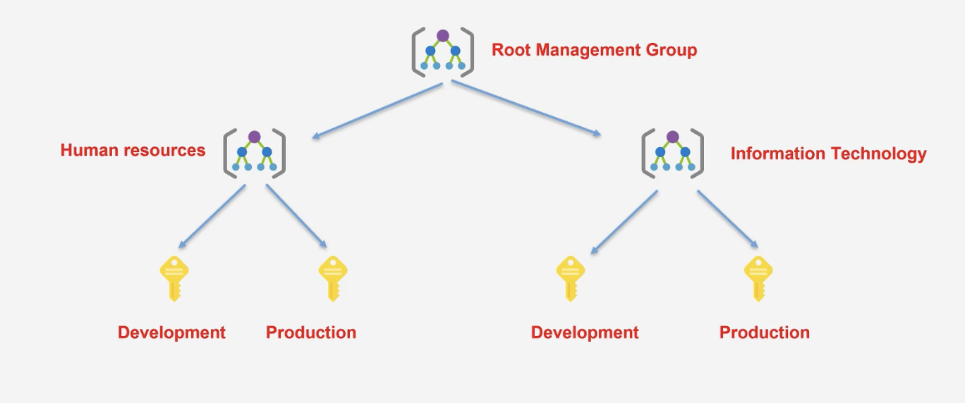

Azure Locks

This provides the ability to ensure that a resource is not accidently deleted or modified.

The locks can be defined at the subscription, resource group or resource level

CanNotDelete - This means that authorized user can still read and modify a resource, but they can’t delete the resource.

ReadOnly -This means that authorized user can read a resource, but they can’t delete or update the resource.